2.1.1   **Agent** :

 an intelligent agent (IA) is an [autonomous](https://en.wikipedia.org/wiki/Autonomous) entity which observes through sensors and acts upon an [environment](https://en.wikipedia.org/wiki/Environment_(biophysical)) using actuators (i.e. it is an [agent](https://en.wikipedia.org/wiki/Software_agent)) and directs its activity towards achieving goals (i.e. it is "[rational](https://en.wikipedia.org/wiki/Rational_choice_theory)", as defined in [economics](https://en.wikipedia.org/wiki/Economics)[[1]](https://en.wikipedia.org/wiki/Intelligent_agent#cite_note-1)). Intelligent agents may also [learn](https://en.wikipedia.org/wiki/Machine_learning) or use [knowledge](https://en.wikipedia.org/wiki/Knowledge_representation) to achieve their goals.

### 2.1.1.1 Goal-based agents:

Goal-based agents further expand on the capabilities of the model-based agents, by using "goal" information. Goal information describes situations that are desirable. This allows the agent a way to choose among multiple possibilities, selecting the one which reaches a goal state. Search and planning are the subfields of artificial intelligence devoted to finding action sequences that achieve the agent's goals.

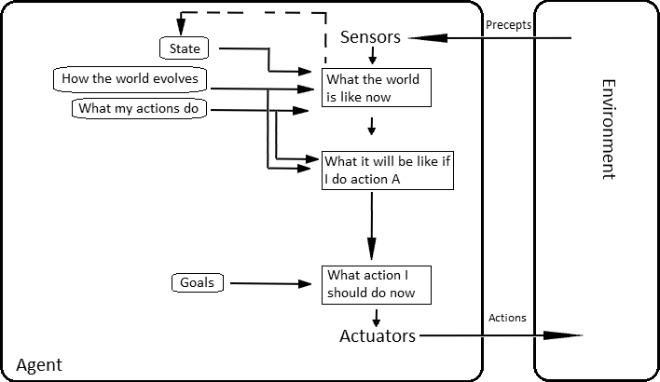

**2.1.2 Multi-Agent Systems :**

Multi-agent systems consist of agents and their environment . Multi-agent systems can be used to solve problems that are difficult or impossible for an individual agent or a [monolithic system](https://en.wikipedia.org/wiki/Monolithic_system) to solve. Intelligence may include some [methodic](https://en.wikipedia.org/wiki/Scientific_method), [functional](https://en.wikipedia.org/wiki/Function_(computer_science)), [procedural](https://en.wikipedia.org/wiki/Algorithm) approach, [algorithmic](https://en.wikipedia.org/wiki/Algorithm) [search](https://en.wikipedia.org/wiki/Search_algorithm) or [reinforcement learning](https://en.wikipedia.org/wiki/Reinforcement_learning). Although there is considerable overlap.

The agents in a multi-agent system have several important characteristics:

* Autonomy: the agents are at least partially independent, self-aware, [autonomous](https://en.wikipedia.org/wiki/Autonomous_agent)
* Local views: no agent has a full global view of the system, or the system is too complex for an agent to make practical use of such knowledge
* Decentralization: there is no designated controlling agent (or the system is effectively reduced to a monolithic system)

**2.1.3 Negotiation in Multi-Agent Systems**

In systems composed of multiple autonomous agents, negotiation is a key form of interaction that enables groups of agents to arrive at a mutual agreement regarding some belief, goal or plan.